Fantastic Faerie Houses – Pixies Session
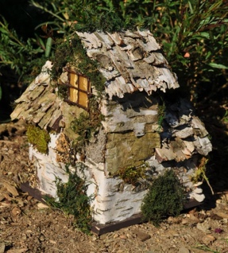
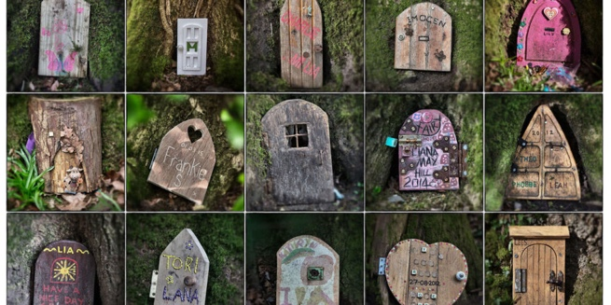
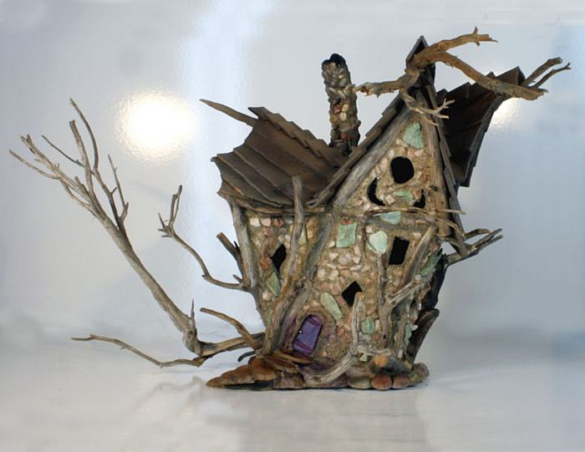
Leaders: Science Teacher Maggie van Boldrik (maggie@eagleschool.org) and Parent Artist Kathy Hoffman

If you ask Maggie whether fairies are real, she’ll tell you that she’s seen no evidence to support or deny their existence! But that won’t stop us from creating these beautiful little houses…just in case!
Who: 3/4s through 7/8s

When: Five Alternating Thursdays, 3:25 - 5:25

September 14 & 28 and October 12 and November 2 & 16

Where: Room 25 to start then outside!

Fee: $107 (including $7 for supplies)

In this after-school activity, we’ll be designing and building faerie houses with natural materials that we’ve collected from the natural areas around Eagle School. We’ll first look at various designs to get some inspiration and then sketch or print out what we’d like to build. When the weather is good, we’ll go out to forage for materials. We may even start by building a little village out in the Promega Woods. As the weather cools down, we’ll take our materials and build, using our creativity and the materials we’ve collected or brought from home. We will have clay, paint, some additional natural materials that Maggie has already collected and various binding materials, including hot glue.

Space is limited to 10, so register soon!

To register, please submit the portion below with payment
(check payable to EAGLE School in the amount of $107)
to the Reception Office by Friday, September 1.
--------------------------------------------------------------------------------------------------------------------------------------

I agree to pick up my child, ___________________________________(Unit______) at 5:30 PM after Faerie Houses – Pixies Session from the Main (east) entrance.

Parent Signature: _______________________________ Parent Name (printed): ______________________

Parent Email Address: ____________________________Best Phone on Thursdays:____________________

